An assessment of a real-time analysis and its impact on dispersion modeling
Caterina Tassone, Marina Tsidulko, Yanqiu Zhu, Lidia Cucurull, Geoff Manikin, Jeff McQueen and Geoff DiMego
NOAA/NCEP/EMC
5200 Auth Rd, Camp Springs, MD 20746,USA
Caterina.M.Tassone@noaa.gov
Abstract The height of the Planetary Boundary Layer (PBL) is an important quantity for certain applications such as dispersion modeling. A dedicated two-dimensional PBL height analysis has been developed as an additional component of NCEP’s Real-Time Mesoscale Analysis. As for other meteorological analysis applications, the quality of the output is dependent on the quality of the input, including the observation. Here we assess the quality and potential for use in the PBL height analysis of a series of candidate observations, including Radiosonde Observations (RAOBS), Aircraft Communications Addressing and Reporting System (ACARS), Cooperative Agency Profilers (CAP), COSMIC satellite Radio Occultation and NWS Next-Rad radar reflectivities. The quality is assessed both by physical plausibility of the measurements and by comparison of the observations and the resulting analysis with independent observations not used in the analysis.
1 Introduction
Accurate estimates of the depth of the atmospheric boundary layer are crucial for applications such as dispersion modeling. In order to improve PBL height predictions used by atmospheric dispersion models, a PBL analysis has been added to the NOAA Real Time Mesoscale Analysis (RTMA). The analysis uses the Rapid Update Cycle (RUC) 13 km model boundary layer height as background for the analysis. Among the candidate observations are derived PBL heights from RAOBS, ACARS, CAP, COSMIC and RADAR data. For each type of data a careful evaluation took place before the decision was made on whether or not to include them in the PBL analysis. In particular, ACARS derived PBL height have been evaluated to assess their temporal and spatial error characteristics. The quality of PBL heights from COSMIC radio occultations and from ground-based radar reflectivity measurements has been assessed by comparing them with collocated ACARS and RAOBS estimates. Finally, a first version of the PBL analysis is verified against independent observations such as the ones collected during the DC PBL experiment.
2 RTMA
The RTMA (Pondeca et al. 2007) is a 2D-VAR based Real-Time Mesoscale analysis that provides 5-km estimates of surface and near-surface conditions on an hourly basis. Based on a two-dimensional modification of NCEP’s Grid-point Statistical Interpolation (GSI) analysis system, the RTMA uses the 13-km one-hour forecast from the Rapid update Cycle (RUC) downscaled to the 5-km RTMA grid as its first guess. The GSI uses surface observations together with this first guess to produce gridded analyzes of 2-m temperature, 2-m specific humidity, 10-m u and v-components of the wind and surface pressure. The PBL height of one-hour RUC forecasts generally shows good agreement with the NAM (WRF-NMM) and with observations.
3 Observations
PBL height observations that will be assimilated into the RTMA require careful screening in order to obtain a high quality analysis. ACARS, RAOBS, COSMIC and RADAR derived PBL heights were first evaluated by comparison with independent measurements from fields experiments and by examining them for their reflection of typical characteristics of PBL heights, e.g. a realistic range of values (between 100m and 3000m), and an identifiable diurnal cycle.
PBL heights from ACARS, RAOBS and CAP profilers are calculated using a Richardson Number method (Vogelezang and Holtslag 1996). Observations of wind, temperature, humidity are used to compute a Richardson Number with the following formula:

${\text{Ri}}_{B}=\frac{\text{gz}(θ(z)−θ(s))}{θ(s)\left[{\left(u(z)−u(z)\right)}^{2}+{\left(v(z)−v(s)\right)}^{2}+{\text{bu}}_{}\right]}$ (1)
The PBL height is defined to be the height where the computed Richardson number for the first time exceeds a value of 0.25 beginning from the surface. Heights derived from RAOBS are generally good and will be retained as observations for the PBL analysis. However, their use is limited by their inherently poor temporal resolution, with the only useful measurement over CONUS made at 00Z. ACARS data are collected more frequently and therefore have the potential to capture the diurnal variation of the PBL height. In order to calculate the PBL height, a vertical profile is constructed using ACARS wind and temperature, specific humidity from RUC analysis and surface observations from a nearby METAR station. Equation (1) is applied using a constant $u_{}$and b=100. Studies on data collected over extended periods of time have shown that ACARS derived PBL heights behave statistically well and show a realistic diurnal variation (Tsidulko et al. 2008). In order to further evaluate and possibly improve the algorithm used to derive PBL heights, ACARS estimations were also compared with measurements collected during the DC field experiment (September 2009). During this experiment, radiosondes were launched at two hour intervals at three different locations in the DC area and PBL heights were subjectively derived from these measurements. Lidar measurements as well as estimates from ground lidar (MPLNET), are also available. Fig 1 shows a time series of PBL heights from ACARS at Baltimore Washington International Airport (BWI) and radiosondes measurements from the DC experiment on the 15th of September. During the hours of maximum BL development ACARS is in good agreement with PBL height derived from radiosondes. However, at 20Z, the ACARS PBL height collapses to 200m, well below both the radiosondes and the lidar estimates (not shown). In order to obtain good agreement, Equation (1) was modified by adding a term of 0.5K to the surface temperature. This term represents a temperature excess, a measure of the strength of the convective thermals in the PBL. This modification proved to be useful in several cases.
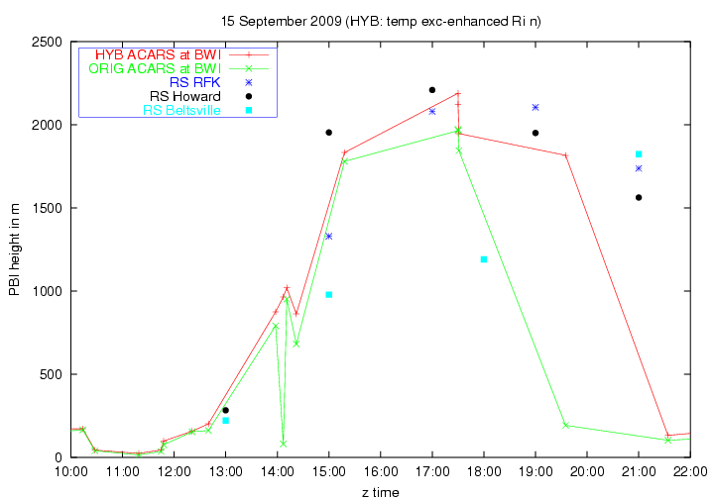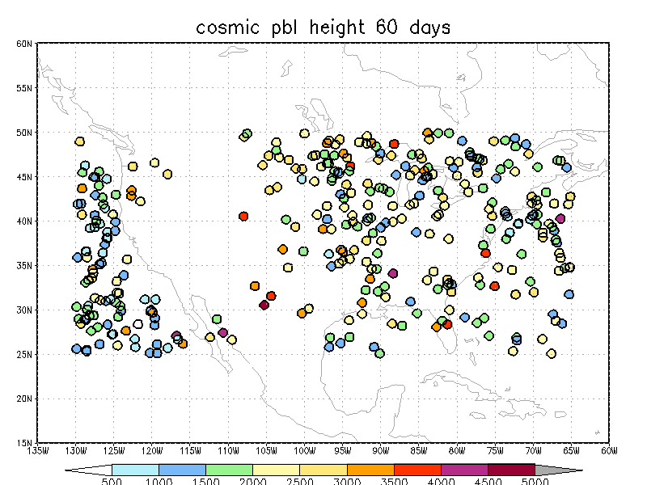
Fig. 1: PBL Heights from observations. DC-experiment (left panel): radiosondes at Beltsville, RFK (R.F.Kennedy Stadium, Washington DC) and Howard U. ACARS at BWI (original –green line; modified surface temperature-red line). COSMIC PBL height for August-September 2009 (right panel).
However, the major problem in the use of the ACARS data is the fact that the data used for the Richardson Number computations do not represent a truly vertical profile. Fig. 2 shows typical trajectories for flights landing in San Francisco and departing from Miami, respectively. In both cases the PBL is detected at several kilometers from the initial surface location. The characteristics of the boundary layer depend on the underlying surface, a problem exacerbated by the fact that many airports are located on the coast, close to the inhomogeneous land-sea transition. In order to address this problem and to ensure appropriate representation of the underlying surface, the surface data closest to the location of the aircraft at each level will be attached to the vertical profile. More work would be needed to ensure that ACARS estimates of PBL height are as accurate as possible, however, the current version of the ACARS estimates have already been demonstrated to be useful for the PBL analysis.

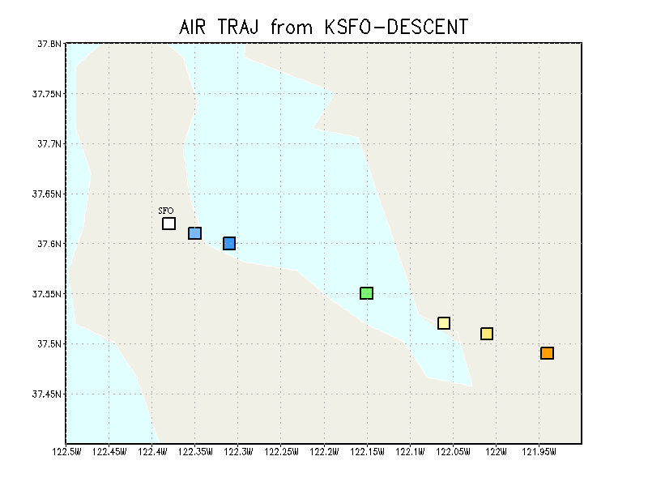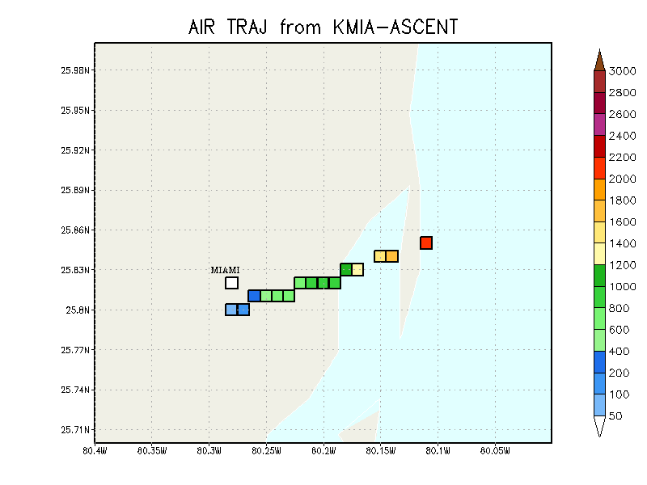
Fig. 2: Examples of aircraft trajectories used for boundary layer calculation. Descent into SFO-20100308 22Z (left panel); ascent from Miami-20100605 21Z (right panel). Color indicates aircraft altitude at horizontal location. Plot ends when PBL height is reached
COSMIC Radio occultations (RO) can be used to determine the depth of the PBL (Sokolovskiy et al. 2007). A large lapse in the bending angle profile, which indicates strong vertical moisture gradient, is used for estimating PBL height. Calculated distributions agree well with observed climatological features and when taking into account several years of data, diurnal variations of PBL height of the ocean was detected. For our study we used two months worth of data (August-September 2009). Values of COSMIC derived PBL heights are within reasonable physical bounds (Fig 1), but due to insufficient data it was not possible to detect a diurnal cycle. The evaluation also included comparison of COSMIC PBL height with collocated ACARS estimates and with the DC experiment measurements. With a one-degree lat/lon collocation criterion, only 17 cases of collocated ACARS and COSMIC data were found. For the DC experiment only two COSMIC PBL heights at about 300km from the DC area were found. For both comparisons, the COSMIC PBL heights are systematically higher, a feature to be expected because of the nature of the measurements. COSMIC data may be a useful data set for PBL analysis. However, more data is needed in order to perform a statistically significant study before including COSMIC observations in the PBL analysis.
Reflectivity collected by the network of Weather Surveillance Radar-1988 Doppler (WSR-88D) radars can also be used to estimate PBL height (Heinselman et al. 2009). A preliminary study showed ambiguous results and these data were not pursued further.
4 Validation of PBL Analysis
The PBL analysis was performed using ACARS and RAOBS derived PBL height as observations and RUC 1-hr forecast as a background. The observation closest in time to the analysis time is selected for assimilation and is combined with the background field according to the specification of observation and background error covariances. The PBL height analysis at the location of BWI is compared to the radiosondes PBL heights available for the DC PBL experiment and to the 1-hr forecast PBLH from RUC. On September 20, a drop in the analysis at 18Z is in disagreement with the experimental data (Fig 3). Triangles show the ACARS data available to the RTMA analysis. For each observation set (one for each of the three DC area airports BWI, IAD and DCA), only the one observation closest to the analysis time is selected and used by the analysis. Many of the observations from IAD at 18-19Z fail to enter the analysis due to having failed this time check. Although this is standard usage for objective analysis, the nature of the PBL height, with its high spatial and temporal variation is such that one might consider using all the available observations rather than just the one closest in time.
Fig. 3 shows the PBL height analysis obtained by using all available observations. The upper cluster of observations (red triangles) is from IAD, while the lower one (cyan triangles) is from BWI, and the analysis at BWI tends towards observations from BWI.

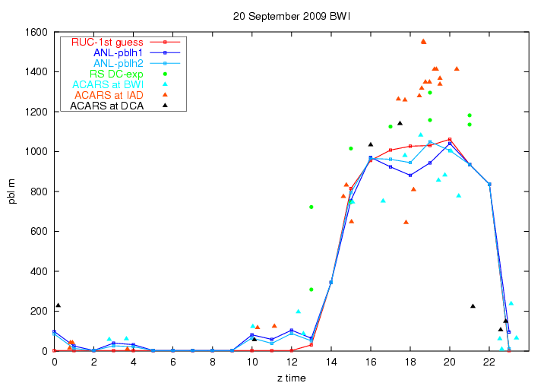
Fig. 3: PBL height from DC experiment: RUC first guess (red line), original analysis (blue line), analysis obtained with all available observations (light blue line), radiosondes from DC experiment (green circles) and ACARS (triangles)
5 Summary
The evaluation of data shows that ACARS-derived PBL heights are a good source of information for the RTMA analysis. Modification of internal parameters in the analysis resulted in a better performance judged by comparison with independent measurements collected during the DC PBL experiment. Validation of the modified analysis will be conducted using measurements from the wind profilers.

References
Heinselman,P.L.,D.J.Stensrud,R.M.Hluchan,P.L.Spencer,P.C.Burke,and K.L.Elmore: Radar reflectivity-based estimates of mixed layer depth. Journal of Atmospheric and Oceanic Technology,26,229-239 (2009)
Pondeca,M.S.F.V.,G.S.Manikin,S.Y.Park,D.F.Parrish,W.S.Wu,G.DiMEgo,J.C.Derber,S.Benjamin,J.D.Horel,S.M.Lazrrus,L.Anderson,B.Colman,G.E.Mann,and G.Mandt: The development of the real time mesoscale analysis system at NCEP.23rd Conf. on IIPS,San Antonio,TX,Amer.Meteor. Soc,P1.10 (2007)
Sokolovskiy,S.V.,C.Rocken,D.H.Lenschow,Y.-H.Kuo,R.A.Anthes,W.S.Schreiner,and D.C.Hunt: Observing the moist troposphere with radio occultation signals from COSMIC.Geophys.Res.Lett. (2007),doi:10.1029/2007GL030458
Tsidulko,M,,J.McQueen,G.DiMego,and M.Ek: PBL verification with Radiosonde and Aircraft data, AGU Fall Meeting, San Francisco, CA.15-19 December 2008
Vogelezang,D.H.P. and A.A..Holtslag: Evaluation and model impacts of alternative boundary-layer height formulations. Boundary-Layer Meteorology 81:245-269 (1996)

