Emissions Updates for National Air Quality Forecasting over the Hawaii Domain
(NOAA Air Resources Lab, January 4, 2010)

Appendix A. Figures supporting the Hawaii Emission Updates (FY 2010)
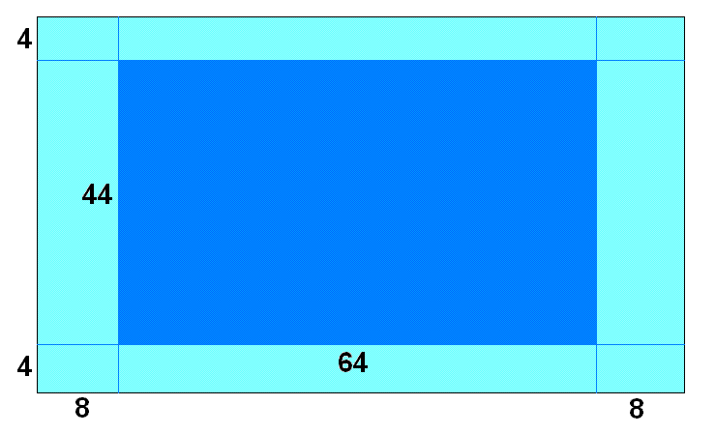
Figure 1. The emission domain and the NAQF system over Hawaii. The emission domain was extended by 4 to 8 cells in each direction. Spatial surrogates were initially generated for the small domain while the NAQF for Hawaii requires emission data for the large domain.

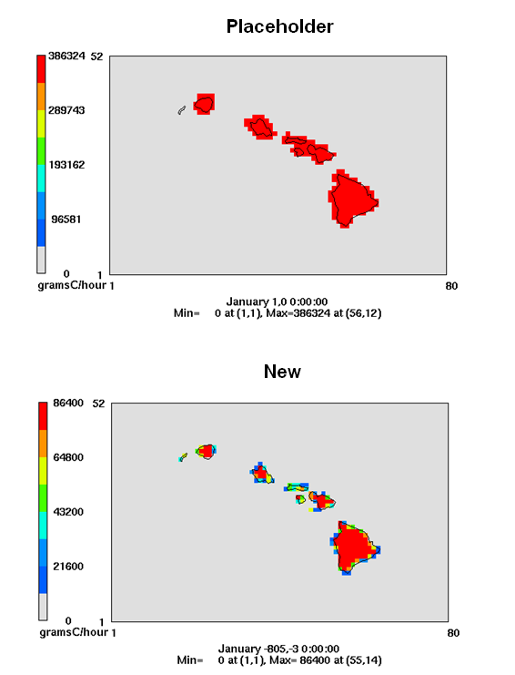
Figure 2. Normalized emission factor for isoprene from the placeholder data and the updated BEIS input data.

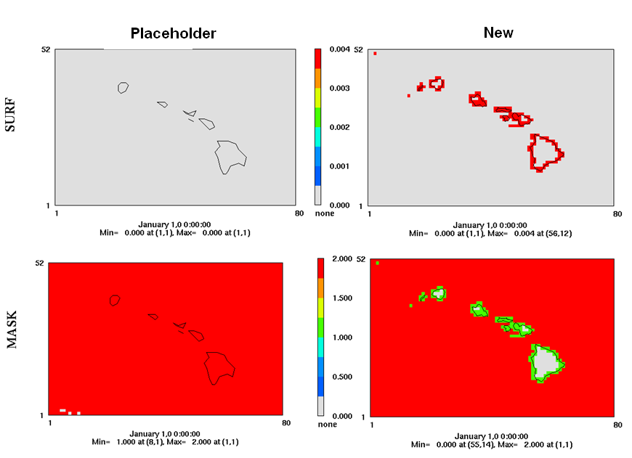
Figure 3. Comparison of the placeholder and the updated OCEAN files. Unlike the all-zero placeholder file, the new OCEAN file enables the NAQF system to dynamically generate sea-salt emissions.

Appendix B: Deliverables from ARL:
- Area source emissions;
- Mobile source emissions;
- Point source emission input data to PREMAQ (inventory, spatial, chemical and temporal matrices);
- USGS-based land use data;
- Updated biogenic emission factor input file (the B3GRD file)
- Sea-salt emission input (the OCEAN file);

