The North American Ensemble Forecast System (NAEFS)
Zoltan Toth¹, Jean-Guy Desmarais², Gilbert Brunet², Peter Houtekamer², Yuejian Zhu¹, Richard Wobus¹, Richard Hogue², Richard Verret², Lawrence Wilson², Bo Cui¹, Gerard Pellerin², Brent Gordon¹,
Ed O’Lenic¹, David Unger¹

¹NCEP Environmental Modeling Center, 5200 Auth Road, Rm. 207, Camp Springs, MD 20746, USA

²Meteorological Service of Canada, CMC, 2121 Trans Canada Highway, Dorval (Quebec) CANADA, H9P 1J3

(Zoltan.Toth@noaa.gov; Jean-Guy.Desmarais@ec.gc.ca)

Abstract: The North American Ensemble Forecast System (NAEFS, see Fig. 1) combines state of the art weather forecast tools, called ensemble forecasts, developed at the Meteorological Service of Canada (MSC), and at the US National Weather Service (NWS). When combined, these tools (a) provide weather forecast guidance for the 1-14 day period that is of higher quality than the currently available operational guidance based on either set of tools alone; and (b) make a set of forecasts that are seamless across the national boundaries between Mexico and the US and the US and Canada. Since both the research/development and operational costs of the NAEFS system are shared by the three participants (MSC, NWS, and the National Meteorological Service of Mexico, NMSM), each weather service can produce higher quality and more extensive weather forecast guidance than they could working on their own.

1. Introduction

Ensemble forecasting. The NAEFS utilizes a relatively new tool, ensemble forecasting, where a numerical representation of the atmosphere, called a Numerical Weather Prediction (NWP) model is run multiple times, with slight perturbations in the initial conditions and the model formulation. The purpose of this approach is to capture all possible weather scenarios. Such an approach can support a probabilistic forecast suite, allowing users to better prepare for extreme weather events by providing early warnings.

2. Project description

Improved forecast quality and utility. For the generation of ensemble forecasts, MSC and NWS use different but equally plausible methods (for data assimilation, NWP modeling, and ensemble perturbation). When forecasts from the two centers are combined, the joint ensemble is expected to better capture the uncertainty in the forecast, leading to enhanced quality. Probabilistic forecast products based on the joint ensemble will in turn have more value for the users of the forecasts in the participating countries, including Mexico.

Applications. The NAEFS forecast suite will contain a common set of probabilistic weather forecast products, to be used by all three participating meteorological services. These will include the probability of extreme weather events, including heavy precipitation, damaging winds, etc. Some of the products will serve synoptic forecasters, as intermediate users, at NWS Weather Forecast Offices (WFOs), NCEP Service Centers, and at the NMSM. Others will be tailored for end users, both in the private sector and for the general public in Canada and the other countries. All three participating weather services are expected to contribute to the design of these products, and will naturally benefit in their daily routine work from the operational generation of these products by the NAEFS system.

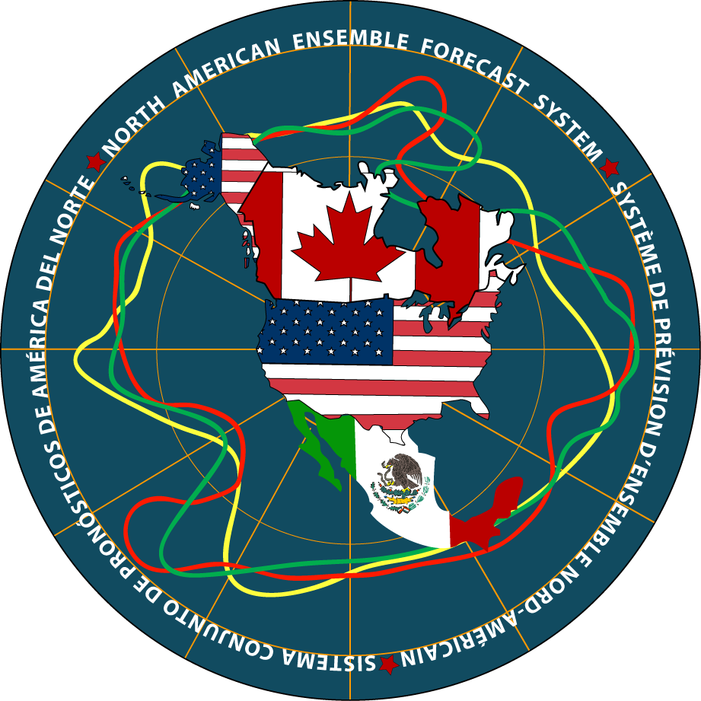

Fig. 1. A graphical depiction of the North American Ensemble Forecast System.

3. Benefits

Accelerated research and development. By sharing the research and development tasks among the participating countries, more new methods can be tested, and at an accelerated pace. This will increase the rate of improvement both in the area of ensemble forecasting, and in the generation and use of weather forecast products.

Cost savings. NWP forecasting involves extensive use of computer resources. One of the most computationally demanding tasks is the generation of an ensemble of forecasts. By combining ensembles from different centers, the participating weather services can produce potentially higher quality forecasts at a fraction of the cost compared to generating all the forecasts themselves.

Fig. 2. Signing of the documents at the Inauguration Ceremony for the North American Ensemble Forecast System. Seated are Marc Denis Everell, Assistant Deputy Minister, Meteorological Service of Canada, General David L. Johnson, Director of US National Weather Service, and Michel Rosengaus, Head of National Meteorological Service of Mexico. Standing are Michel Beland of MSC, Stephen Lord, Louis Uccellini and Zoltan Toth of NCEP/NWS, and Rene Lobato-Sanchez of NMSM.

4. Operational Implementation

Initial Operational Capability. As a first step in the development of the NAEFS system, the two ensemble generating centers, the Canadian Meteorological Center (CMC) of MSC and the National Centers for Environmental Prediction (NCEP) of the NWS, started exchanging ensemble forecast data on an operational basis in September 2004. At each center, routinely generated forecast products are made based on both sets of ensembles, but not yet with a combined ensemble.

Next phases of implementation. In the next phase of NAEFS development, expected to be completed by February 2006, forecast products will be generated based on the joint ensemble. Before combining the forecasts from the two centers, each set of forecasts will undergo a statistical post-processing procedure to reduce their systematic errors. A common set of new products will be developed and prepared operationally at each ensemble generating center, also providing a backup functionality for the other center. Additional forecast products will be introduced in 2007 and 2008, as the product suite of the NAEFS is improved and expanded.

5. Organizational background

Historical background. Discussions about joint ensemble forecasting development efforts were initiated at a meeting of high level officials from the MSC and NWS in February 2003. A workshop was convened in May 2003 with experts from the MSC and NWS, where planning for the research, development, and operational implementation work for the NAEFS system began. Basic planning activities were completed by October 2003 with the completion of the NAEFS Plan, after which intensive work for the Initial Operational Capability (IOC) implementation began. The IOC of the NAEFS was successfully implemented on schedule in September 2004. The National Meteorological Service of Mexico (NMSM) became involved with the NAEFS system in October 2004. The NAEFS was officially inaugurated at a ceremony held at NCEP in Camp Springs, MD (USA) in November 2004 (see Fig. 2). There the leaders of the three weather services, MSC, NMSM, and NWS, signed the Inauguration Document of the North American Ensemble Forecast System (Fig. 3).

International connections. The Met Office of the United Kingdom plans to join the NAEFS system after their ensemble forecast system becomes operational, possibly in 2006. The NAEFS system will also serve as a prototype for the THORPEX Interactive Grand Global Ensemble (TIGGE), as part of a broader international research collaboration under the auspices of World Meteorological Organization (WMO) sponsored World Weather Research Program, called THORPEX. The NAEFS was also noted as a prime example of collaborative work under the Global Earth Observing System of Systems (GEOSS) by Conrad C. Lautenbacher, Jr., Vice Admiral, U.S. Navy (Ret.), Under Secretary of Commerce for Oceans and Atmosphere and NOAA Administrator.

Acknowledgements:

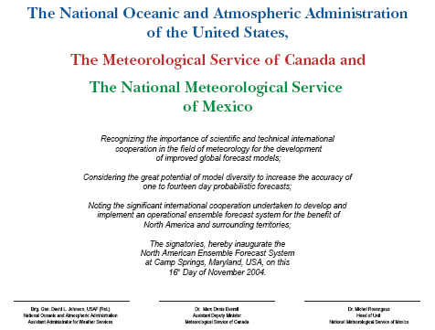
The authors would like to acknowledge the guidance and support provided by their management leadership, in particular, Michel Beland and Pierre Dubreuil at MSC, and Louis Uccellini, Stephen Lord, Jack Hayes, and Fred Toepfer at NWS.

Fig. 3. The document signed by the Leaders of the three participating national weather services at the Inauguration Ceremony of the NAEFS system.

Reference:

For further information, see:
http://wwwt.emc.ncep.noaa.gov/gmb/ens/NAens-wshop-2004.html and links therein.

