Advancements in Tropical Cyclone Intensity (and Intensity Change) Forecasts: An Operational Perspective from the High-Resolution NCEP/NOAA Hurricane Weather Research and Forecast (HWRF) Modeling System
- Introduction:
During the past two-three years, significant progress has been accomplished in the tropical cyclone (TC) track, intensity and structure forecasts under the auspices of and support from the United States (US) National Oceanic and Atmospheric Administration (NOAA)’s Hurricane Forecast Improvement Project (HFIP, Gall et al. 2013). In particular, for the first time, a very high-resolution (3 km) deterministic numerical weather prediction (NWP) model, known as the Hurricane Weather Research and Forecast (HWRF) modeling system, developed as a joint project by the Environmental Modeling Center (EMC) and the Hurricane Research Division (HRD) and implemented at the National Centers for Environmental Prediction (NCEP), has shown comparable and at times superior TC intensity forecast skills compared to the best performing statistical models. The HWRF model is now paving the way for removing the roadblocks to improvements in the operational TC intensity forecasts, which have had virtually stagnant skill for the last two decades. This report summarizes the recent advancements and future hurricane model development activities at NCEP in collaboration with various NOAA, academic and international partners for providing improved operational numerical forecast guidance on TC track, intensity and structure to the forecasters at the National Hurricane Center (NHC), the Central Pacific Hurricane Center (CPHC) and the US Navy’s Joint Typhoon Warning Center (JTWC).
- NOAA Hurricane Forecast Improvement Project (HFIP):
Since its start in 2010, NOAA’s HFIP has been providing a unified organizational infrastructure and funding for NOAA and other agencies to coordinate the hurricane research needed to significantly improve guidance for hurricane track, intensity, and storm surge forecasts. HFIP’s 5 year (for 2014) and 10-year goals (for 2019) are:
- Reduce average track errors by 20% in 5 years, 50% in 10 years for days 1 through 5.
- Reduce average intensity errors by 20% in 5 years, 50% in 10 years for days 1 through 5.
- Increase the probability of detection (POD) for rapid intensification (RI) to 90% at Day 1 decreasing linearly to 60% at day 5, and decrease the false alarm ratio (FAR) for rapid intensity change to 10% for day 1 increasing linearly to 30% at day 5.
- Extend the lead-time for hurricane forecasts out to Day 7 (with accuracy equivalent to that of the Day 5 forecasts when they were introduced in 2003).
It is hypothesized that the HFIP goals could be met with high-resolution (~10-15 km) global atmospheric numerical forecast models run as an ensemble in combination with, and as a background for, regional models at even higher resolution (~1-5 km). HFIP expects that its intensity goals will be achieved through the use of regional models with a horizontal resolution near the core finer than about 3 km. While the track forecast improvements from the NCEP Global Forecast System (GFS) have been documented elsewhere in this report (REF), this section focuses on the intensity forecast improvements obtained from the NCEP HWRF modeling system.
- NCEP HWRF Modeling System:
Specialized regional TC models developed at NCEP such as the Geophysical Fluid Dynamics Laboratory (GFDL) hurricane model (Bender et al. 2007) and the HWRF model (Tallapragada et al. 2014a) are designed to provide real-time TC forecasts to the NHC for the North Atlantic (NATL) and Eastern North Pacific (EPAC) basins, to the CPHC for the Central Pacific (CPAC) basin and to the US Navy’s JTWC for all tropical ocean basins including North Western Pacific (WPAC), North Indian Ocean (NIO), Southern Indian Ocean (SIO) and Southern Pacific (SP). Until recently, the GFDL model was one of the primary track and intensity prediction tools used by the operational forecasters after it became operational in 1994 for NHC and the Navy version of GFDL model (GFDN) for JTWC in 2002. With an aim to replace the hydrostatic GFDL model with a more advanced atmosphere-ocean coupled non-hydrostatic model with storm following nests capable of producing high-resolution TC forecasts, the HWRF modeling system was developed and implemented at NCEP in 2007. Figure 1 shows the regions where HWRF and GFDL/GFDN models are currently operated in real-time.
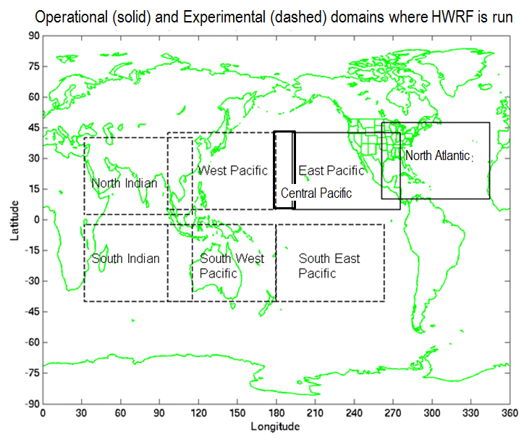
Figure 1: Tropical oceanic basins covered by the HWRF model for providing real-time TC forecasts. Solid lines represent operational HWRF/GFDL domains at NCEP. Dashed lines show the areas where experimental forecasts are provided by HWRF in real-time.
- HWRF Forecast Improvements in the North Atlantic Basin:

In the early 2000s, the development of an operational TC forecast system with a non-hydrostatic dynamic core was revived at the NCEP/Environmental Modeling Center (EMC) to better forecast TC intensity, structure, and rapid intensity changes. In fulfillment of this goal, the Hurricane Weather Research and Forecasting (HWRF) modeling system was established in 2007 to provide the National Hurricane Center (NHC) with operational track and intensity guidance. The original HWRF model operated at a resolution of 27 km for the static domain and 9 km for the single movable nest. Meanwhile, scientists at the Atlantic Oceanographic and Meteorological Laboratory’s Hurricane Research Division (HRD) developed an experimental research version of HWRF called HWRFx (Zhang et al. 2011) to target the intensity change problem at higher resolution (about 3 km, Gopalakrishnan et al. 2011). Central to the development of the high resolution HWRF is the advancement of the surface and boundary layer parameterization schemes. For the first time, inner core data collected by NOAA WP-3D research aircraft were used as the basis to redesign the boundary layer parametrization for high-resolution hurricane applications (Gopalakrishnan et al. 2013). Significant improvements to modeled boundary layer structure as well as size predictions were demonstrated with those advancements. Supported by HFIP, a triply nested high resolution HWRF (27:9:3) system with improved physics calibrated to match observations was run in real-time HFIP demonstration mode in 2011.

Based on “R2O type”, HIFP demonstration experiments that illustrated significant impacts of high resolution for TC predictions, scientists at EMC worked with NOAA research, in particular, HRD, and other academic partners and implemented major changes to original operational version of HWRF resulting in a new operational HWRF for the 2012 hurricane season. The central improvement was the triple-nest capability (27:9:3) that included a cloud-resolving innermost grid operating at 3 km horizontal resolution along with several improvements to the physics schemes based on observational findings and advanced vortex initialization data assimilation techniques for better representation of the inner core structure of the storms. Apart from obtaining significant improvements in the track forecast skill compared to previous versions, 2012 version of the operational HWRF has conclusively demonstrated the positive impact of resolution on storm size and structure forecasts (Tallapragada et al. 2013).
The 2013 version of the operational HWRF made significant additional improvements in track, intensity and structural prediction of TCs by taking better advantage of the high-resolution capability built in the 2012 HWRF (Goldenberg et al. 2014). For the first time, the HWRF Data Assimilation System (HDAS), a GSI-basd one-way hybrid ensemble-variational data assimilation scheme was implemented to assimilate inner core observations from the NOAA P3 aircraft Tail Doppler Radar (TDR) data, when available. One of the highlights of the 2013 HWRF configuration retrospective T&E, performed on a vast sample of three hurricane seasons (2010-2012), was the remarkable reduction of intensity forecast errors. Results shown in Fig. 2 indicated that the HWRF model outperformed the statistical models for intensity prediction in the 2 to 3-day forecast period. Historically, statistical models have been more skillful than dynamical models for hurricane intensity prediction.

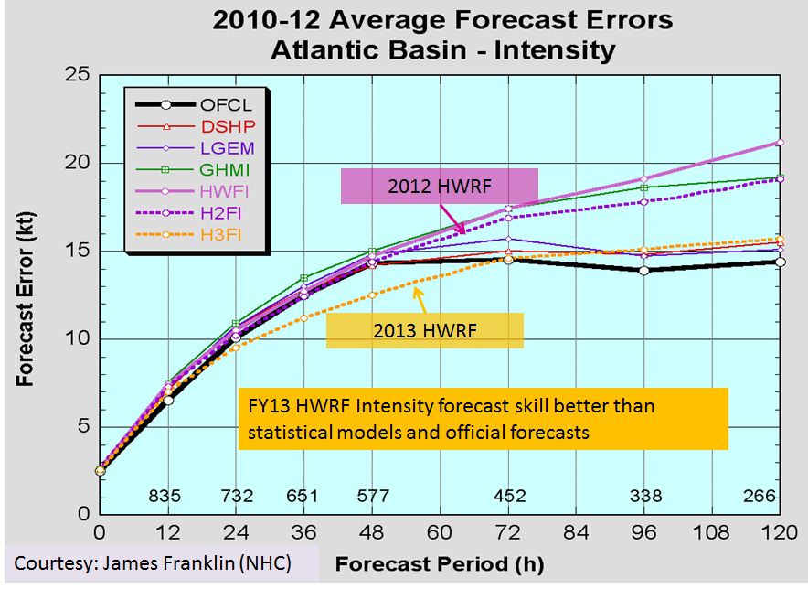
Figure 2: Average intensity forecast errors for 2010-2012 hurricane seasons from 2013 version of HWRF model (H3FI; 27:9:3) compared to 2012 version (H2FI; 27:9:3) , original operational HWRF (HWFI; 27:9), GFDL model (GHMI), statistical models LGEM (Linear Growth Equation Model) and DSHP (Decay Statistical Hurricane Intensity Prediction System). Dark black line represents NHC Official Forecast errors as a function of time, and the number of cases verified at each forecast period is shown along the x-axis.
Upgrades to the HWRF system are continuing on an annual basis, with the new configuration of HWRF model implemented for operations at the start of each new hurricane season so that NHC forecasters have access to improved hurricane guidance. Systematic evaluation of each individual upgrade (and combinations thereof) for multiple hurricane seasons is the key element of model development activities at NCEP supported by HFIP, and this process ensures appropriate testing of model stability, reliability and expected performance levels in real-time operations. Important upgrades for the 2014 version of the operational HWRF include increased vertical resolution (61 levels), higher model top (2 hPa), assimilation of aircraft reconnaissance dropsonde data in the inner core, and implementation of a new, high-resolution version of the POM-TC (MPIPOM-TC) ocean model. Evaluation of 2014 HWRF upgrades have shown further improvements in track and intensity forecasts, with the average track errors now comparable to the GFS model and average absolute intensity errors better than NHC official forecasts at all forecast times. Figure 3 shows the cumulative improvements obtained from the operational HWRF during the last four years (2011-2014), highlighting the role of HWRF in providing more accurate track and intensity forecast guidance for NHC.
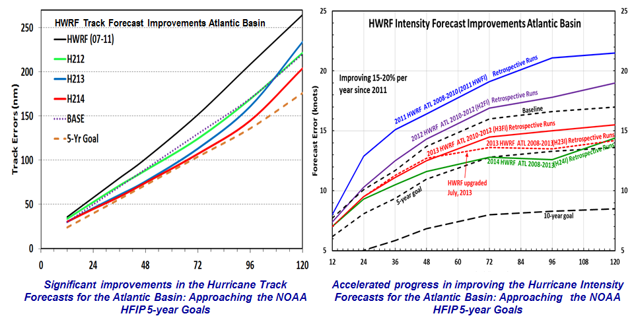
Figure 3: Cumulative forecast improvements in the NATL basin from operational HWRF over the years since 2011. Each configuration of HWRF was evaluated for multiple hurricane seasons. The dashed lines show HFIP baseline (BASE) and 5-year goal for track and intensity errors. The samples are non-homogeneous as indicated in the right-hand panel.
  - Experimental HWRF forecasts for the WPAC basin in support of JTWC
The accelerated progress accomplished with the HWRF model in the NATL basin prompted the HWRF team at EMC to provide experimental real-time guidance to JTWC for typhoon forecasts in the WPAC basin starting in 2012, using the same operational HWRF model implemented at NCEP except for the ocean coupling. Evaluation of the model performance in 2012 showed lower forecast errors from the HWRF model compared to other operational regional models currently used by JTWC (Evans and Falvey 2013; Tallapragada et al. 2014b). Intensity forecasts also showed improved performance as compared to other regional models with much reduced forecast errors during the first 24 h owing to better vortex initialization. These experimental forecasts were performed with computational resources and support provided by HFIP, and delivered to JTWC with about 90% real-time reliability achieved through specially established procedures. Given the positive performance of the HWRF model in the WPAC basin during the 2012 season, the HWRF team at EMC continued their efforts to provide real-time forecasts in 2013 and 2014 using the 2013 upgrade of the HWRF model.
Performance of the HWRF model during the real-time experiments in the 2012-2013 typhoon seasons is shown in Fig. 4 where non-homogeneous seasonal statistics of the absolute TC track forecast errors, the absolute intensity errors, and the intensity bias errors between the 2013 and 2012 seasons are provided (Tallapragada et al. 2014b, c). One notices very significant improvement of the 2013 HWRF as compared to the 2012 version with both the track and intensity forecast errors reduced at all forecast lead times.
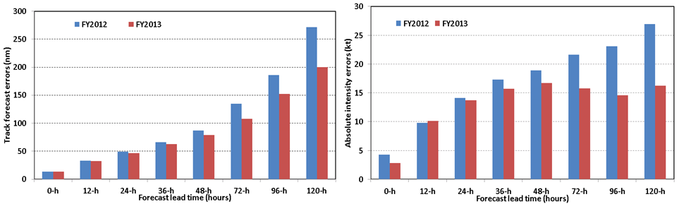
Figure 4. Left: Non-homogenous comparison of the absolute track forecast errors between the 2012 HWRF version during 2012 (blue columns) and the 2013 HWRF version during 2013 (red columns), Right: similar to (a) but for the absolute intensity forecast errors.
Given the fact that the WPAC basin was very active in 2013 with 34 storms, of which five were super typhoons (STY) including the extremely powerful landfalling STY Haiyan, the improvement in the intensity and track forecast errors at the 3-5 day lead times from HWRF model indicates that HWRF could improve the forecasts of structure and development of TCs in the WPAC basin. The performance and reliability of the HWRF forecasts allowed JTWC to officially include HWRF as one of their track and intensity consensus models. Figure 5 shows the homogeneous verification of HWRF relative to the suite of other operational models used by JTWC, namely COAMPS-TC (Naval Research Laboratory Coupled Ocean-Atmosphere Prediction System for TCs, referred to as COTC), GFDN, NCEP GFS, and the official JTWC forecasts for WPAC typhoons in 2013. HWRF outperformed all other regional models in terms of track and intensity forecasts, with HWRF’s track errors comparable to the global GFS forecasts except at day 4, and HWRF’s absolute intensity errors demonstrated consistently better forecasts than all other models during the entire 5-day forecast times.
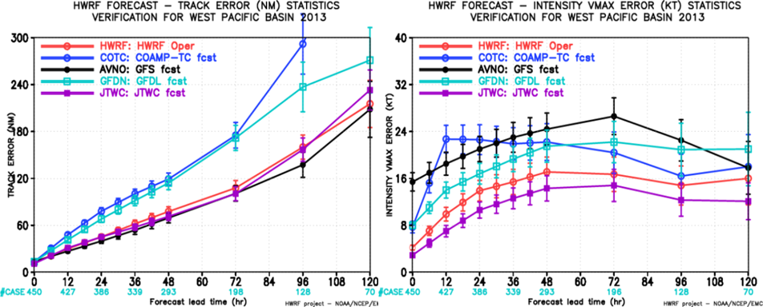
Figure 5: Verification of the absolute track errors (left) and absolute intensity errors (right) during 2013 typhoon in the WPAC basin for the HWRF (red), COAMPS-TC (blue), AVNO (GFS) (black), GFDN (cyan), and JTWC’s official forecast (purple). The numbers below the x-axis denote the number of cases verified for each forecast time.
  - Evolution of HWRF as a unique high-resolution regional hurricane model with global coverage
The successful demonstration of the HWRF model performance for WPAC basin led to expanding the scope of the real-time experimental forecasts from HWRF for all world tropical oceanic basins. HWRF forecast guidance for track, intensity, structure and rainfall for all 6 tropical cyclones that formed in the NIO basin during 2013 were provided to the India Meteorological Department (IMD) Cyclone Warning Division (CWD) including for the very severe cyclone Phailin. IMD has been routinely using the operational forecast guidance from the NCEP models, and acknowledged the superior quality of the products they received from NCEP (Mohapatra, personal communication). An example illustrating the HWRF model forecasts for the life cycle from genesis to landfall of VCS Phailin is shown in Figure 6. The improved numerical model forecast guidance for movement, intensity, structure, and storm surge 4-5 days prior to the landfall of TC Phailin and enhanced warning products generation and dissemination systems collectively helped disaster management to evacuate over a million people in India from likely affected areas to cyclone shelters, safe houses, and inland locations.
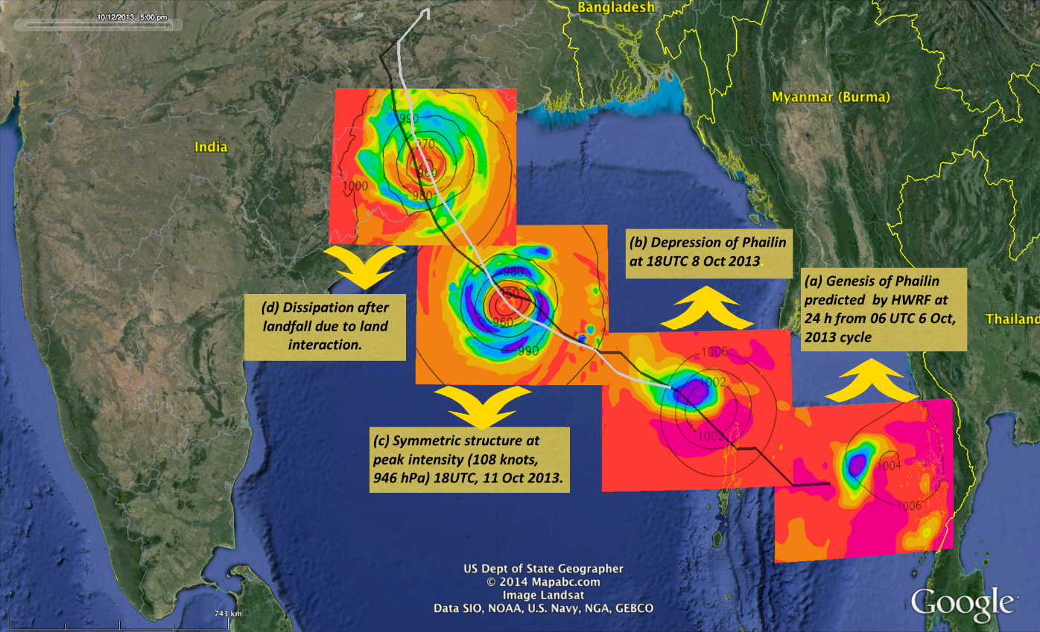
Figure 6: HWRF forecast of the life-cycle of TC Phailin starting from (a) genesis at 06 UTC 7 Oct 2013, (b) formation of depression on 8 Oct 2013, (c) intensification, and (d) dissipation. Shading depicts the model-simulated microwave satellite imagery at the top of the atmosphere and contours represent minimum sea level pressure (hPa). The black line represents the best track from JTWC and the white line is the HWRF predicted track from 00 UTC 10 October 2013.
Track and intensity forecast error statistics (Fig. 7) for all 6 tropical cyclones that formed in the NIO basin during 2013 indicated the superior performance of the HWRF model at almost all forecast times compared to other model guidance received by JTWC.
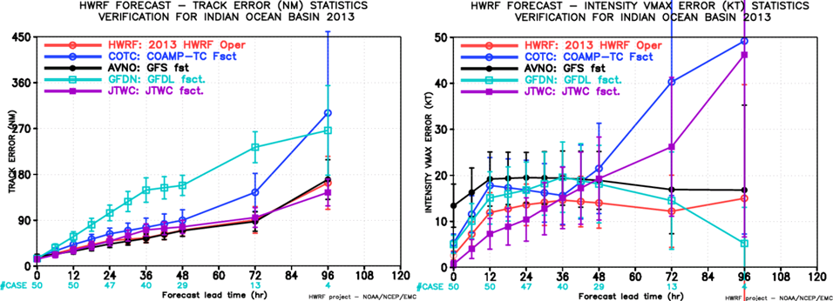
Figure 7: Verification of the average absolute track errors (left) and average absolute intensity errors (right) for the NIO basin in 2013. The numbers below the x-axis denote the number of cases verified for each forecast time.
  - Rapid intensification and Intensity Change forecasts from HWRF: A major accomplishment
Improving rapid intensification (RI) forecasts is one of the highest priorities for TC forecasters at NHC and JTWC, and has been recognized as the most challenging aspect of TC research. Much of the stagnation in the RI forecast skill is rooted in our lack of understanding on when and how RI takes place in different environmental conditions and the historic inability of dynamical models to adequately predict the multi-scale processes that produce an RI event. The impressive intensity forecast performance from the new operational HWRF also demonstrated its improved ability in detecting and forecasting RI, as shown through extensive numerical experiments and observations for Hurricane Earl, a hurricane which intensified even when the environmental vertical wind shear was very large (Chen and Gopalakrishnan 2014).
RI events appear more frequently in WPAC compared to other basins, thus allowing for extensive examination of the capability of the HWRF model in forecasting these events. Using an idealized configuration, Kieu et al. (2014) demonstrated that the onset of RI in the HWRF model is determined by a specific constraint in the model storm’s dynamic and thermodynamic structure (i.e., phase-lock condition). Specifically, the HWRF model vortex has to possess three basic ingredients for the RI onset to occur, namely: i) a warm anomaly of 1-3 K around 400-300 hPa, ii) a moist column with relative humidity >95% within the storm central region, and iii) low-level tangential flow ≥15 m s⁻¹ (Fig. 8a). Examples of the vertical structure of model storms right at the onset of RI about 24-h into integration for a forecast of STY Usagi initialized at 1800 UTC 16 September (Fig. 8b) and for a forecast of STY Soulik that was initialized at 0600 UTC 7 July (Fig. 8c) show strikingly similar and coherent structure with all three components of the phase-lock condition met at the RI onset (Tallapragada et al. 2014d).
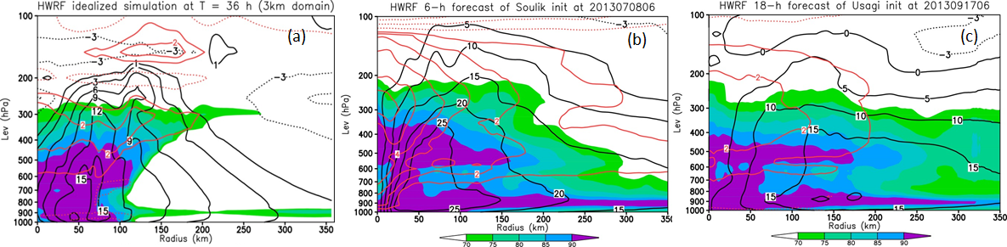
Figure 8: (a) Radius-height cross section of the relative humidity (shaded, unit %), the tangential wind (black contours at intervals of 3 ms⁻¹), and potential temperature anomalies with respect to the far-field environment (red contours at interval of 10K, solid/dotted contours for positive/negative values) in an idealized experiment with the HWRF model compared to analysis of storm vertical structure at the time of RI onset for (b) 6-h forecast of STY Soulik and (c) 18-h forecast of STY Usagi.
Verification of the probability of detection (POD) and the false alarm rate (FAR) of RI forecasts for the WPAC basin during 2013 indicated that the HWRF model outperformed all other models used by JTWC. Specifically, the POD index for RI forecast (at >30kt intensity change criteria) in HWRF is 0.23. While the POD index is still quite low, it is far better than other models as well as the 2012 version of the HWRF model (Tallapragada et al. 2014d).
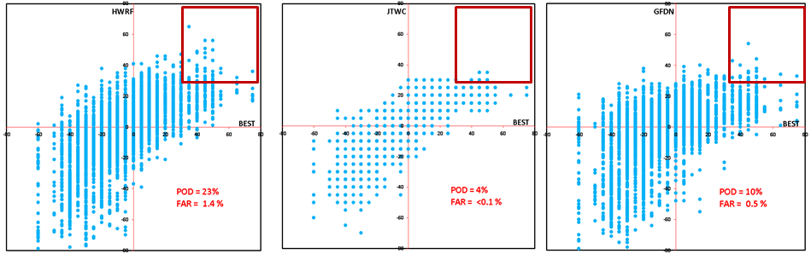
Figure 9: Scatter plots of the 24-h change of the maximum 10-m wind from JTWC best track observations (BEST, x-axis) and the real-time model forecasts (y-axis) for (a) HWRF, (b) JTWC and (c) GFDN forecasts in 2013 WPAC basin. Red boxes denote the points that the models captured the observed RI.
To further examine the ability to predict a general TC intensity change instead of focusing solely on RI, the RI criteria is relaxed by a simple use of 1 kt change in 12 h. Figure 10 compares the POD and FAR indices for the intensity trend forecasts for all models along with the JTWC official forecasts at different forecast lead times. HWRF again shows promising performance as compared to other models with the POD index increased from 0.75 at 12-h lead time to 0.92 at 72-h lead time, and the FAR index decreased from 0.5 at 12-h lead time to 0.32 at 72-h lead time.
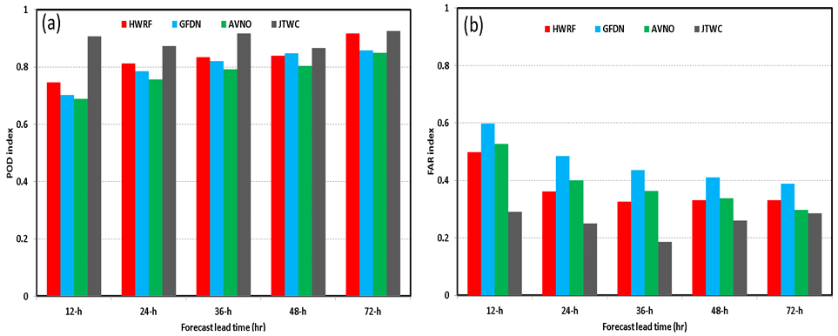
Figure 10. Comparison of the (a) POD and (b) FAR for intensity change of 1 kt in 12 h for the HWRF (red), GFDN (cyan), GFS (green), and JTWC (gray) for the 2013 WPAC basin.
  - High-Resolution Regional Ensemble Forecasts for improved hurricane predictions:
HFIP believes that the best approach to improving hurricane track forecasts, particularly beyond four days, involves the use of high-resolution global models, with some run as an ensemble. However, global model ensembles are likely to be limited by computing capability for at least the next five years to a resolution no finer than about 15-20 km, which is inadequate to resolve the inner core of a hurricane. The favorable results with the new triply-nested (27:9:3) HWRF model has confirmed that the inner core must be resolved to see reliably accurate hurricane intensity forecasts. Maximizing improvements in hurricane intensity forecasts will therefore likely require high-resolution regional models, also run as an ensemble. In 2013, HFIP and EMC conducted a real-time experiment on the HFIP computing infrastructure in Boulder where the HWRF system was run as an ensemble. The basic model used in the ensemble was identical to the operational HWRF for 2013. A 20-member ensemble was run where the initial- and boundary-condition perturbations were from the NCEP Global Ensemble Forecast System (GEFS). Additionally, the model physics were perturbed by adding a stochastic component to the convective trigger function in the operational HWRF. Figure 11 compares the intensity and track forecasts of the operational model (red line) and the ensemble mean (blue line) from the ensemble experiment in the Atlantic in 2013. Because there were few long-lived storms in the Atlantic this season, there are not enough cases beyond 72 h to draw reliable conclusions for 4-5 day forecasts. However, Fig. 11(a) shows significant improvements in the track forecast out to 72 h. Figure 11(b) shows even greater improvement in the intensity forecast, approaching 50% at some lead times.
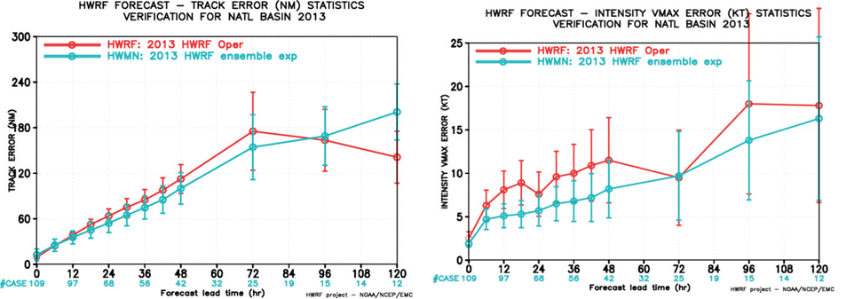
Figure 11: 2013 HWRF Experimental ensemble track and intensity forecast performance for the NATL basin. Red lines show the operational HWRF and blue the 20-member HWRF ensemble mean (HWMN). The ensemble model was identical to the operational HWRF model run at 3km resolution.
In order to estimate the upper bound of the track/intensity forecast skill for the HWRF ensemble prediction system, a concept of Maximum Potential Forecast Skill (MPFS), or Minimum Potential Forecast Error, is calculated from the forecasts by choosing the ensemble member that is closest to the truth as the final forecast. Assuming the best track information for the next 5 days is available at the analysis time; the average distances between each individual ensemble member and corresponding observed track/intensity are calculated and ranked. Figure 12 shows the track and intensity forecast errors based on MPFS forecasts, compared with HWMN, H213, as well as the forecast errors from HFIP 5 and 10 year goals. The forecast error difference between MPFS and HWMN illustrates the potential forecast skill improvement we can obtain with the current HWRF ensemble prediction system.
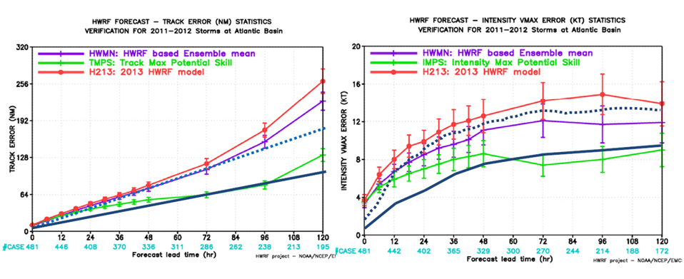Figure 12: The mean track errors (nautical miles) and the mean intensity errors (kts) for the 2011-2012 hurricane seasons in Atlantic basin for observed track based MPFS (left panel, tracks) and observed intensity based MPFS (right panel, intensity), compared with HWMN, H213, as well as forecast errors from HFIP 5 year goal (blue dash line) and 10 year goal (blue solid line). The numbers below the x-axis denote the number of cases verified for each forecast time. (Zhang et al., 2014)

  - Future directions for HWRF
The major HWRF upgrades for the past few years provide a solid foundation for improved TC intensity prediction. Future advancements to the HWRF system include implementing advanced physics packages, such as land-surface model (LSM), radiation, PBL, and microphysics, increasing the number of HWRF model vertical levels, and raising the model top. Future advancements to atmospheric initialization include assimilation of cloudy and all-sky radiances from various satellites, and additional observations from aircraft and/or Unmanned Aerial Vehicles (UAVs). Those include flight level data, dropsondes, and surface winds obtained with the Stepped-Frequency Microwave Radiometer (SFMR). In order to make use of these newly expanded observations, several advanced data assimilation techniques are being explored within the operational and research hurricane modeling communities, including EnKF and hybrid EnKF-4D-VAR approaches. Using this data to improve hurricane initialization has become a top priority in both the research and operational communities.
To include the dynamic feedback of surface waves on air-sea processes and the ocean, HWRF will be coupled to an advanced version of the NCEP wave model, the Wave Watch III (WW3). Eventually, this system will be fully coupled to a dynamic storm surge model to hopefully create more accurate predictions of storm surge and forecasts of waves on top of storm surge to improve the forecasts of the impact of landfalling storms on coastal regions. To address inland flooding and inundation associated with landfalling storms, HWRF will also be coupled to a comprehensive Land Surface Model (Noah LSM) to provide better precipitation forecasts for landfalling storms thus providing improved input for hydrology and inland inundation models. Other advancements to the HWRF modeling system include advanced products tailored to serve Weather Forecast Offices (WFOs) along the coastal regions, enhanced model diagnostics capabilities, and high-resolution ensembles.
Enhancements to the HWRF modeling infrastructure include a much larger outer domain with multiple movable grids, and an eventual transition to NOAA’s Environmental Modeling System (NEMS), which can provide a global-to-local scale modeling framework.
References:
Bender, M., I. Ginis, R. Tuleya, B. Thomas, and T. Marchok, 2007: The Operational GFDL Coupled Hurricane–Ocean Prediction System and a Summary of Its Performance. Mon. Wea. Rev., 135, 3965–3989.
Gall, R., J. Franklin, F. Marks, E. N. Rappaport, and F. Toepfer, 2013: The Hurricane Forecast Improvement Project. Bull. Amer. Meteor. Soc., 94, 329–343.
Goldenberg, B.S., S. G. Gopalakrishnan , X. Zhang, V. Tallapragada, S. Trahan, T. Quirino, F. Marks, and R. Atlas, 2014: The 2012 Triply Nested, High-Resolution Operational Version of the Hurricane Weather Research and Forecasting System (HWRF): Track and Intensity Forecast Verifications. Submitted to Wea. Forecasting.
Chen, H and S.G. Gopalakrishnan, 2014: A Study on the Asymmetric Rapid Intensification of Hurricane Earl (2010) using the HWRF System. Submitted to J. Atmos. Sci.
Kieu, C.Q., V. Tallapragada, and W. Hogsett. 2014: Vertical structure of tropical cyclones at onset of the rapid intensification in the HWRF model, Geophys. Res. Lett., 41, 3298–3306.
Tallapragada V, Kieu C, Kwon Y, Trahan S, Liu Q, Zhang Z, Kwon I, 2013: Evaluation of storm structure from the operational HWRF model during 2012 implementation. Mon Weather Rev. doi:10.1175/MWR-D-13-00010.1
Tallapragada, V., L. Bernardet, Gopalakrishnan, S., Y. Kwon, Q. Liu, T. Marchok, D. Sheinin, M. Tong, S. Trahan, R. Tuleya, R. Yablonsky, and X. Zhang, 2014a: Hurricane Weather and Research and Forecasting (HWRF) Model: 2014 scientific documentation, 99 pp.
Tallapragada, V., C. Q. Kieu, , S.G. Trahan, Q. Liu, Z. Zhang, Y. Kwon, B. Strahl. 2014b. Forecasting Tropical Cyclone for the North-Western Pacific Basin using the NCEP Operational HWRF. Part I. Real-time Experiment in 2012 (submitted to Weather and Forecasting, draft manuscript available at http://www.emc.ncep.noaa.gov/gc_wmb/vxt/pubs/hwrf_wpac_part1.pdf)
Tallapragada, V., C. Q. Kieu, S.G. Trahan, Q. Liu, Z. Zhang, Y. Kwon, 2014c. Forecasting Tropical Cyclone for the North-Western Pacific Basin using the NCEP Operational HWRF. Part II. Real-time Experiment in 2013 (submitted to Weather and Forecasting, draft manuscript available at http://www.emc.ncep.noaa.gov/gc_wmb/vxt/pubs/hwrf_wpac_part2.pdf)
Tallapragada, V. and C. Kieu, 2014d: Real-Time Forecasts of Typhoon Rapid Intensification in the North Western Pacific Basin with the NCEP Operational HWRF Model. Tropical Cyclone Research and Review, 2014, 3(2): 63-77.
Gopalakrishnan, S. G., F. Marks, X. Zhang, J.-W. Bao, K.-S.Yeh, and R. Atlas, 2011: The experimental HWRF System: A study on the influence of horizontal resolution on the structure and intensity changes in tropical cyclones using an idealized framework. Mon. Wea. Rev., 139, 1762–1784.
Gopalakrishnan, S. G., F. Marks, J. A. Zhang, X. Zhang, J.-W.Bao, and V. Tallapragada, 2013: A study of the impacts of vertical diffusion on the structure and intensity of the tropical cyclones using the high-resolution HWRF system. J. Atmos. Sci., 70, 524–541.
Evans, A. D., and R. J. Falvey, 2013: Annual Joint Typhoon Warning Center tropical cyclone report. Available at: http://www.usno.navy.mil/NOOC/nmfc-ph/RSS/jtwc/atcr/2012atcr.pdf.
Zhang, X., T. Quirino, K.-S. Yeh, S. Gopalakrishnan, F. Marks, S. Goldenberg, and S.Aberson, 2011: HWRFx: Improving hurricane forecasts with high-resolution modeling. Comp. Sci. Eng., 13, 13-21.
Zhang, Z., V. Tallapragada, C. Kieu, S. Trahan and W. Wang, 2014: HWRF based Ensemble Prediction System using Perurbations from GEFS and Stochastic Convective Trigger Function. Submitted to Trop. Cyc. Res. Rev.

